**Assignment No. 13**

**Create a workmail for your organization**

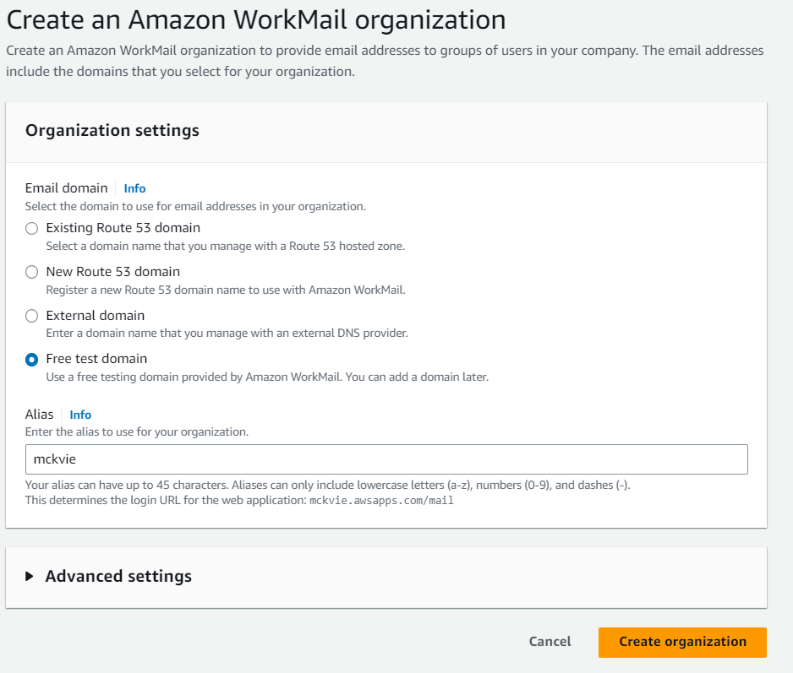

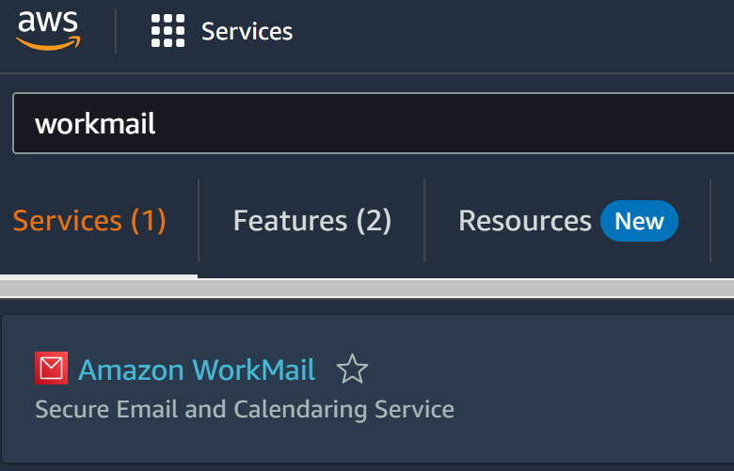

**Select “Free test domain” in the organization settings and click on “Create organization”**

**Visit** **aws.amazon.com** **and Sign in.Click on the search field and type “workmail” in the search field and select Amazon WorkMail. Click on “Create organization”**

**1.….**.

**2.**

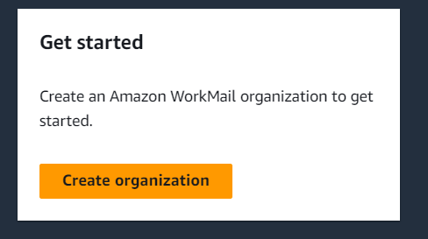

**Click on the organization which was just created.On the left panel select users and then click on “Create user”**

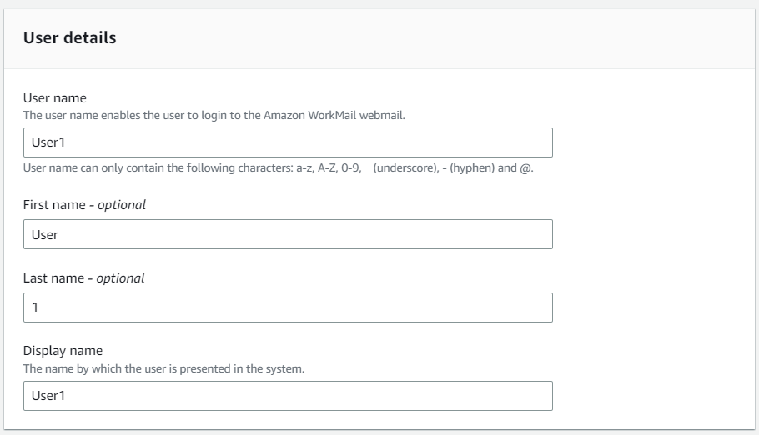

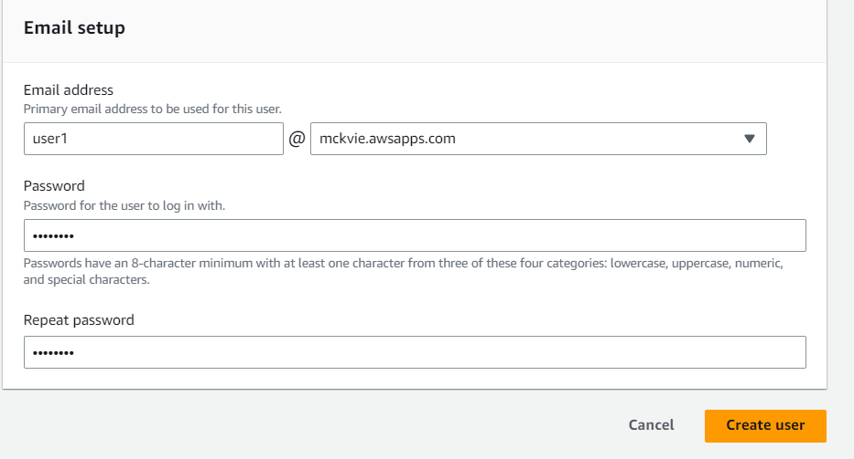

**Setup the user email and click on “Create user”**

**3.**

**4.….**.

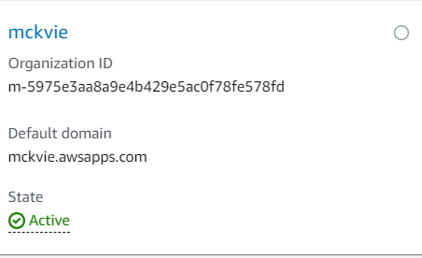

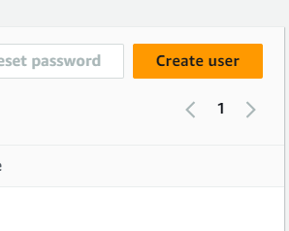 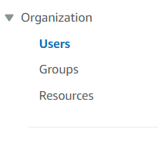

**Create two such users.Go back to organization dashboard and click on the organization created by you. Now click on the Amazon WorkMail web application link.**

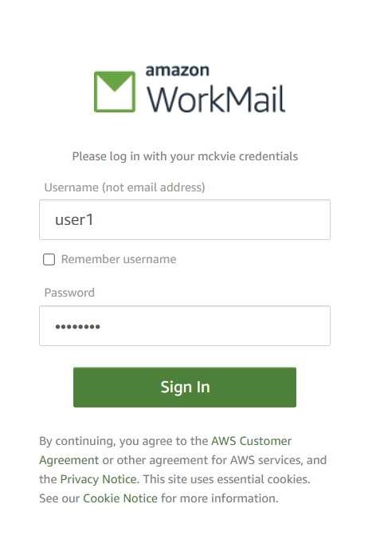

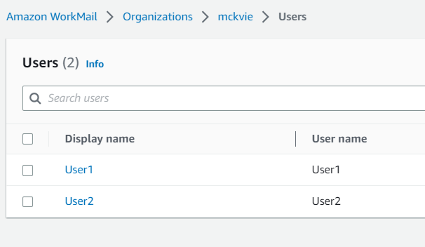

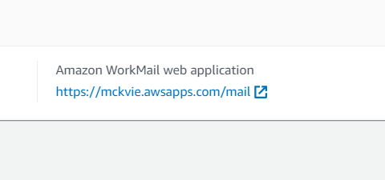

**Login to the amazon workmail by any of the user of your organization’s workmail**

**7.….**.

**6.**

**Check if the email is received by the other user of the same organization.**

**Hence organization’s workmail is setup successfully.**

**8**.

**7.**

**Send an email from one user account of the organization to the another.**

